

**Project 381.**

**Database work done.**

**Jochemus Taljaard.**

Contents

**Delete procedures.** 3

**Insert Procedure.** 5

**Select procedure.** 7

**Update procedure.** 9

# **Delete procedures.**

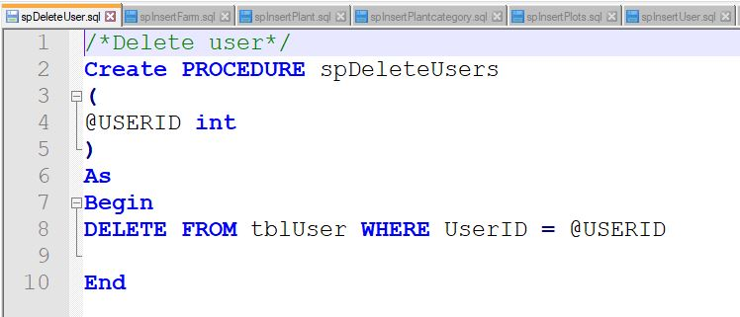

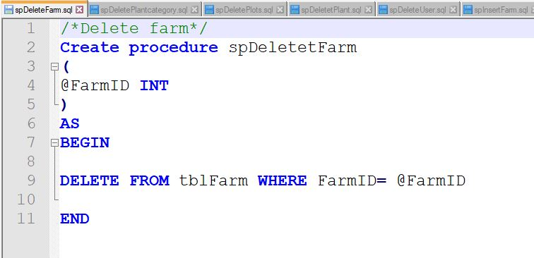

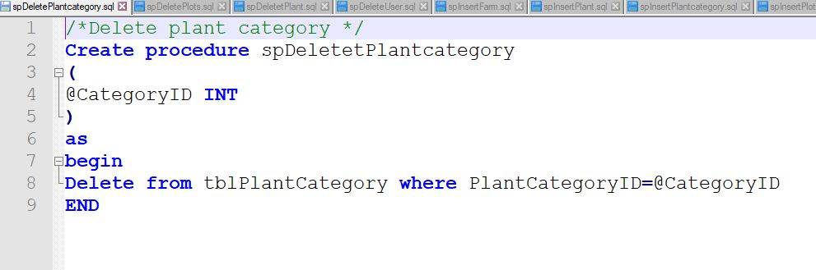

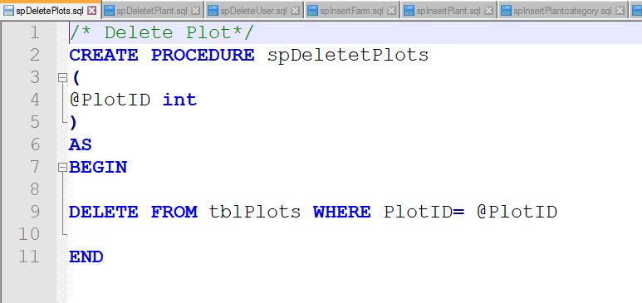

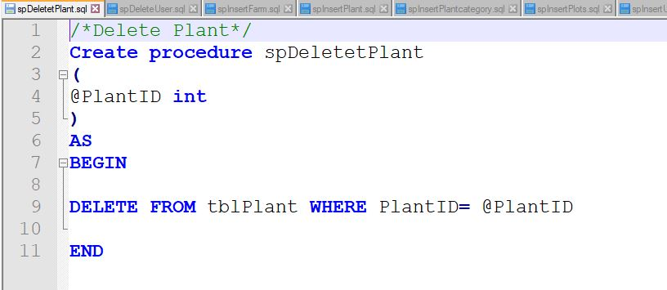

The above mentioned procedures will be used to remove a specific row from the database using the specific id that will be provided from the user.

# **Insert Procedure.**

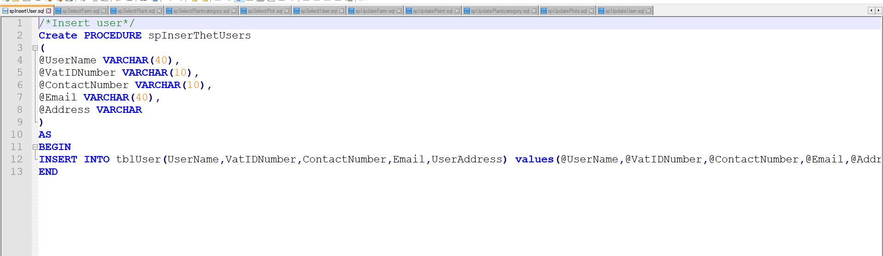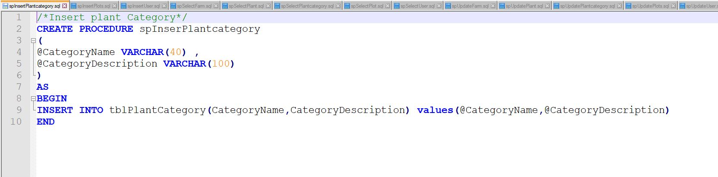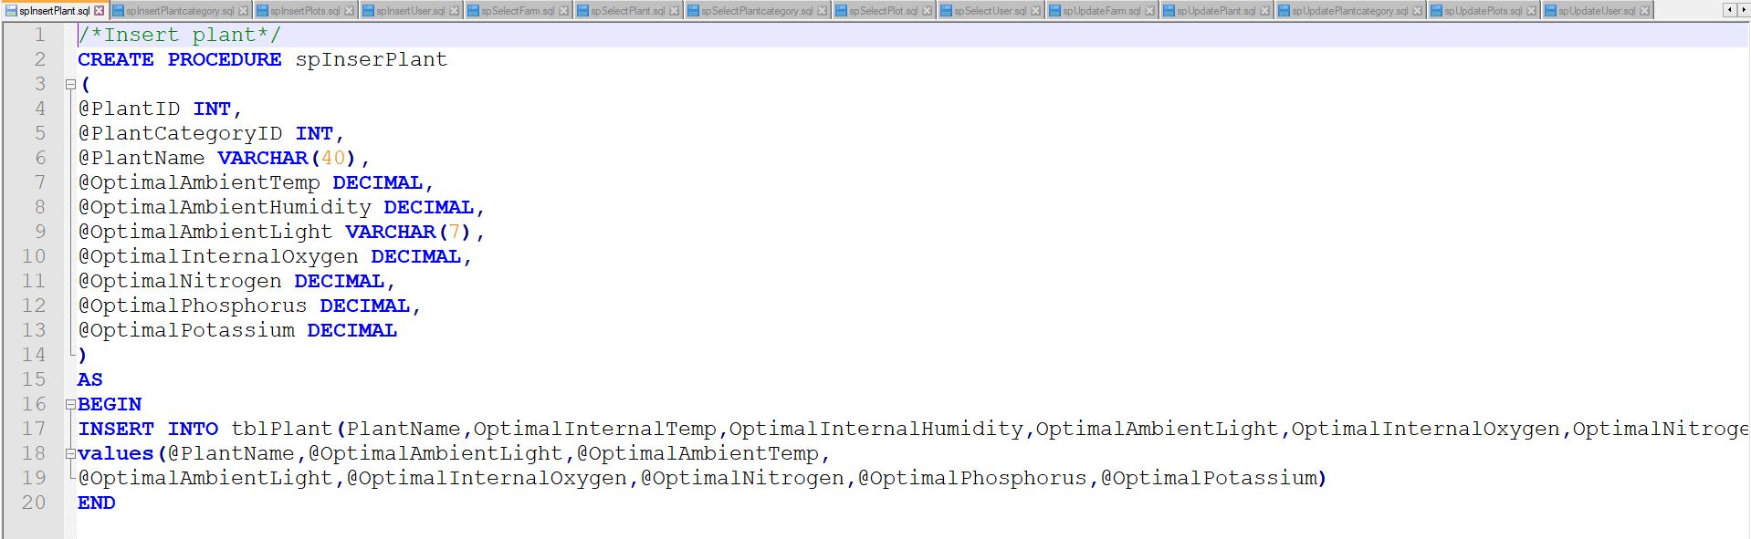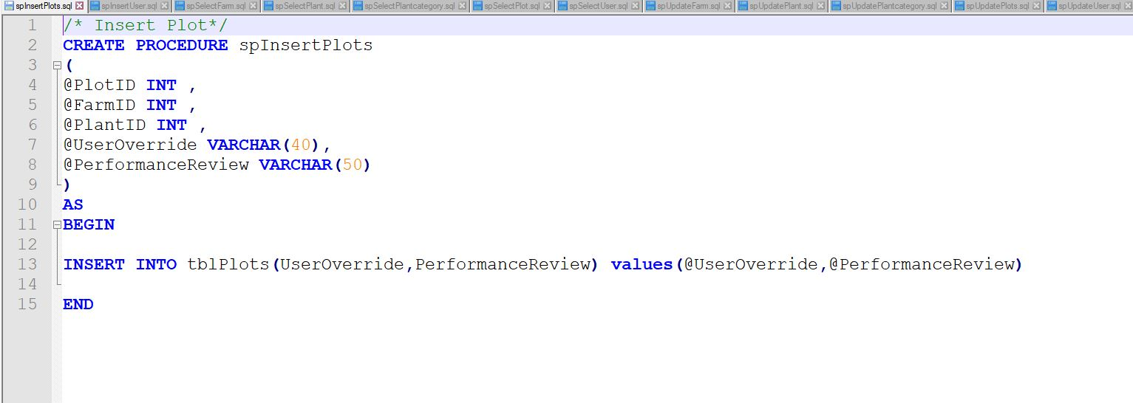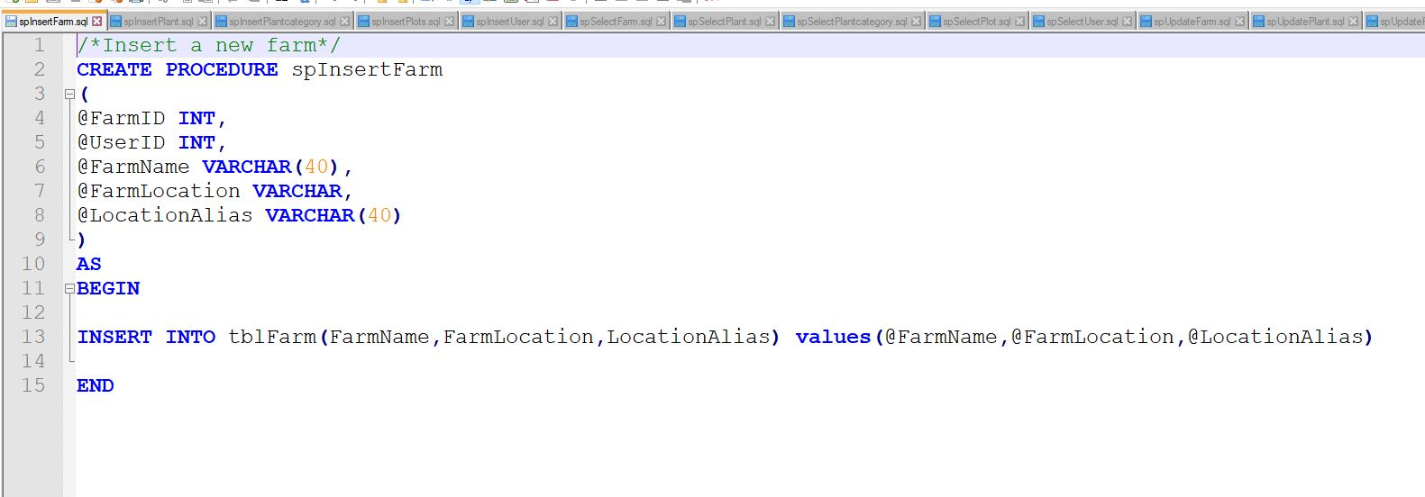

The above mention procedure will gather all the information from the user and add the information to the database.

# **Select procedure.**

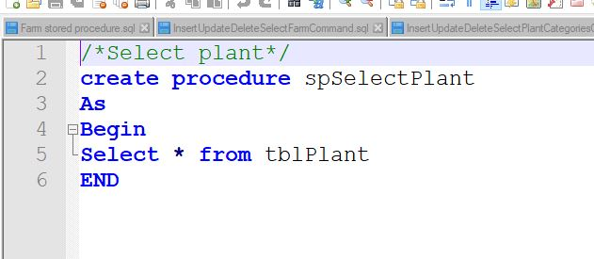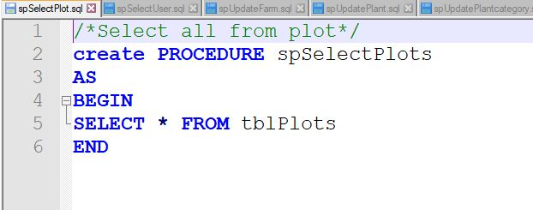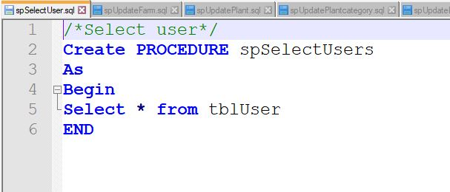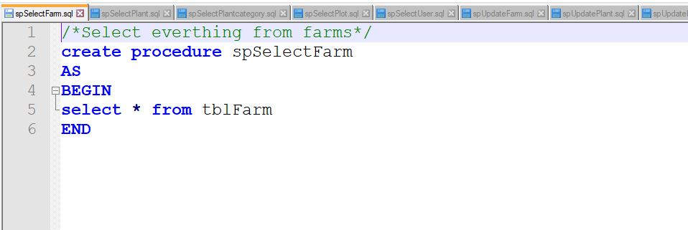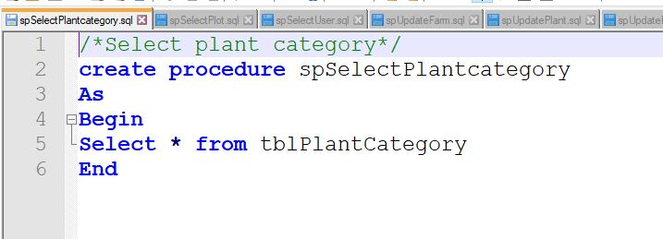

The above mention procedure will select everything in the table users, so that we can view the all the information that had been submitted in the database.

# **Update procedure.**

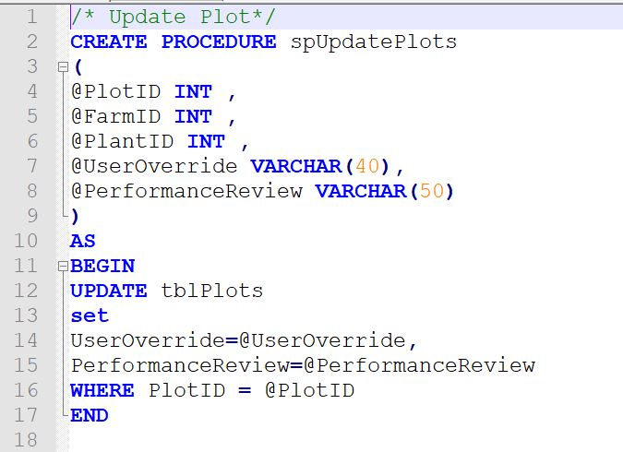

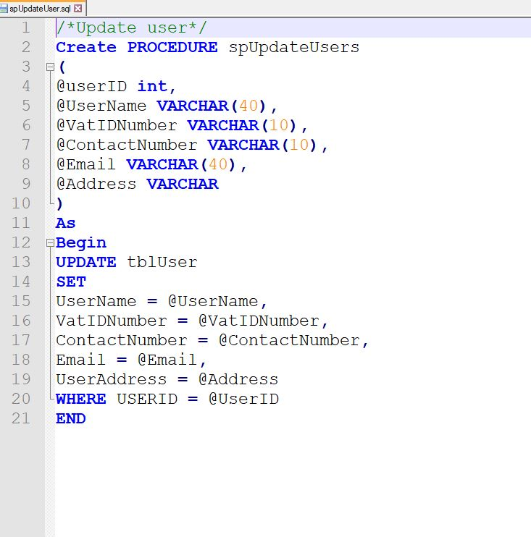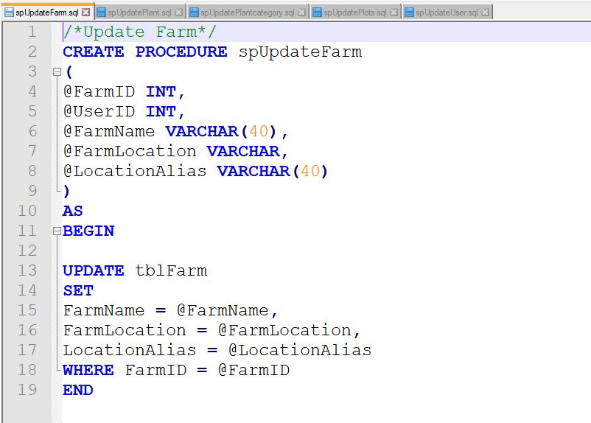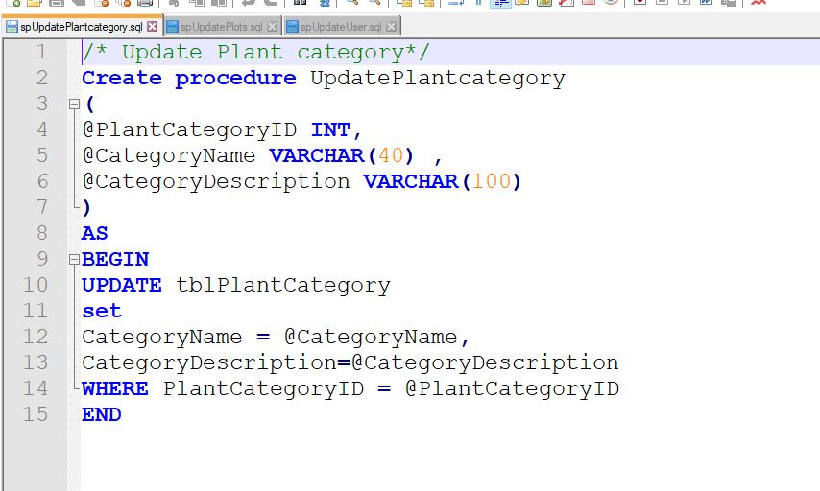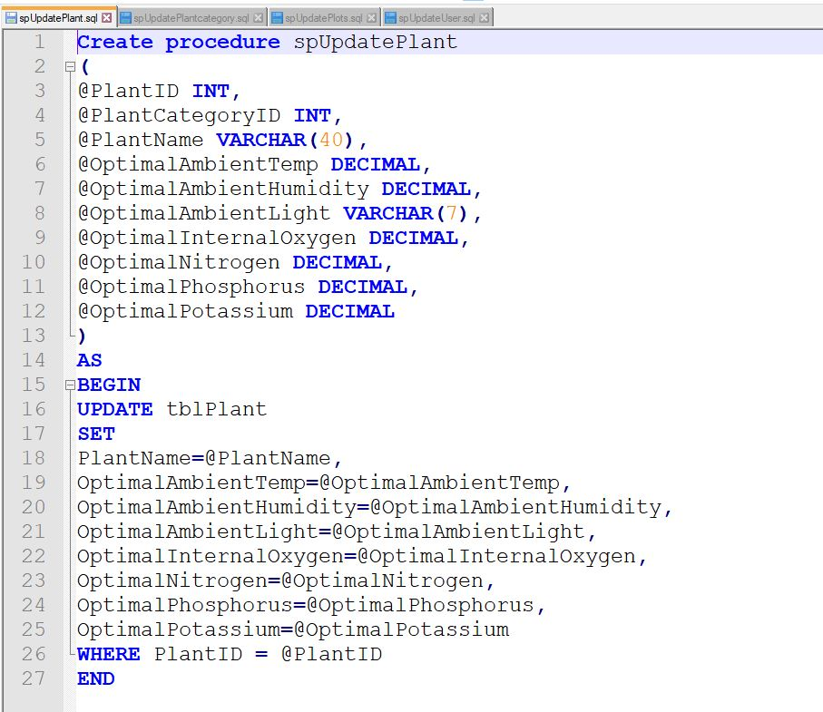

All of the above stored procedures are used to modify the information in the tables.